**Basic Pratice of Programming JobSheet 3**



**From:**

AL AZHAR RIZQI RIFA’I FIRDAUS

**Class:**

1 I

**Absence:**

01

**Major:**

Information Technology

**Study Program:**

Informatic Engineering

**Assignment**

1. Code :

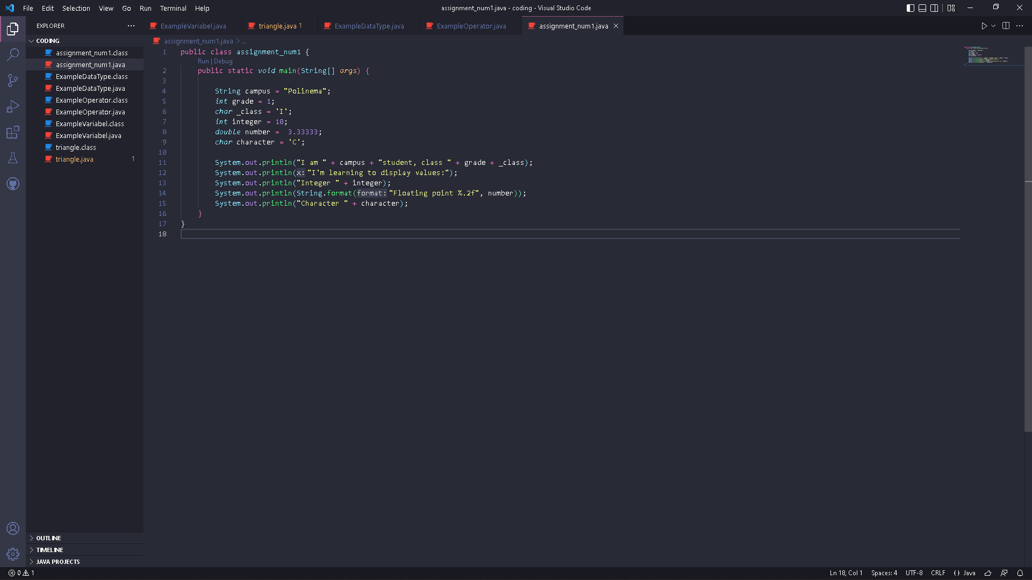

Result :

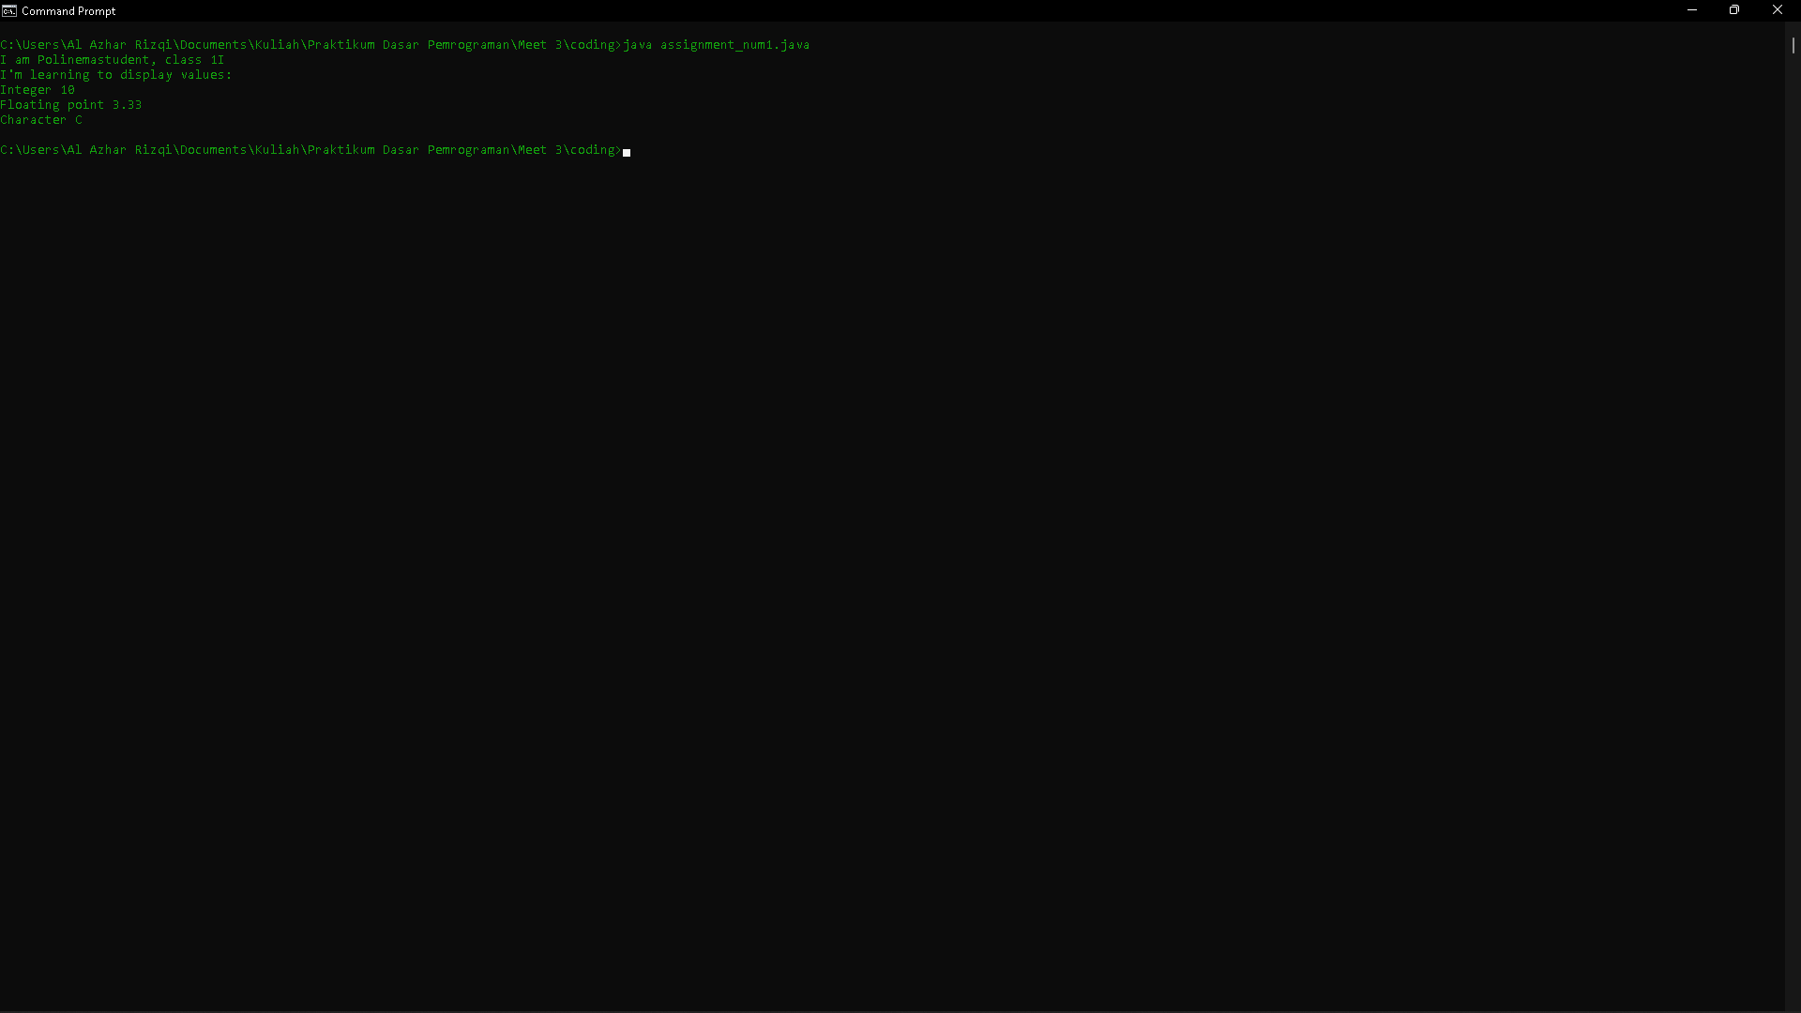

1. Code :

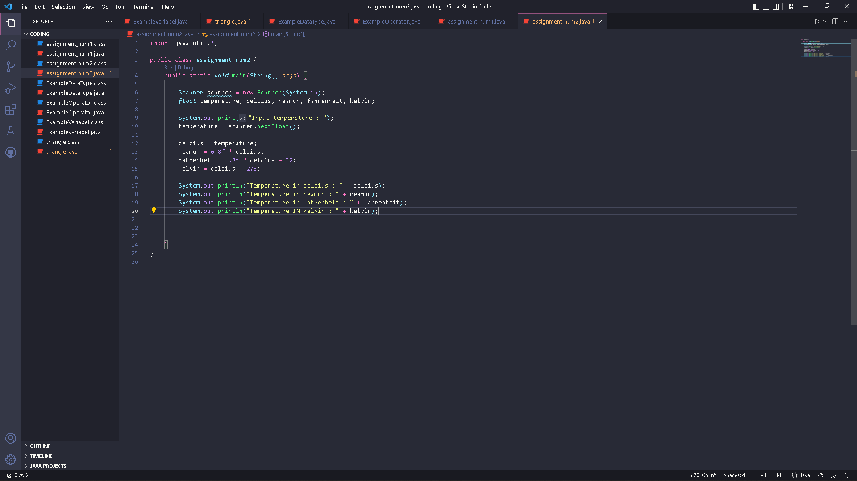

Result :

